CUBE Query

"What is the total quantity sold and average amount in sales across each product categories and across each Channels and overall total of them at different levels?"
SELECT
p.prod_category,
ch.channel_class,
SUM(s.quantity_sold) AS total_quantity_sold,
AVG(s.amount_sold) AS average_amount_sold
FROM
sales s
JOIN
products p ON s.prod_id = p.prod_id
JOIN
channels ch ON s.channel_id = ch.channel_id
GROUP BY
CUBE(p.prod_category, ch.channel_class)
ORDER BY
p.prod_category, ch.channel_class;

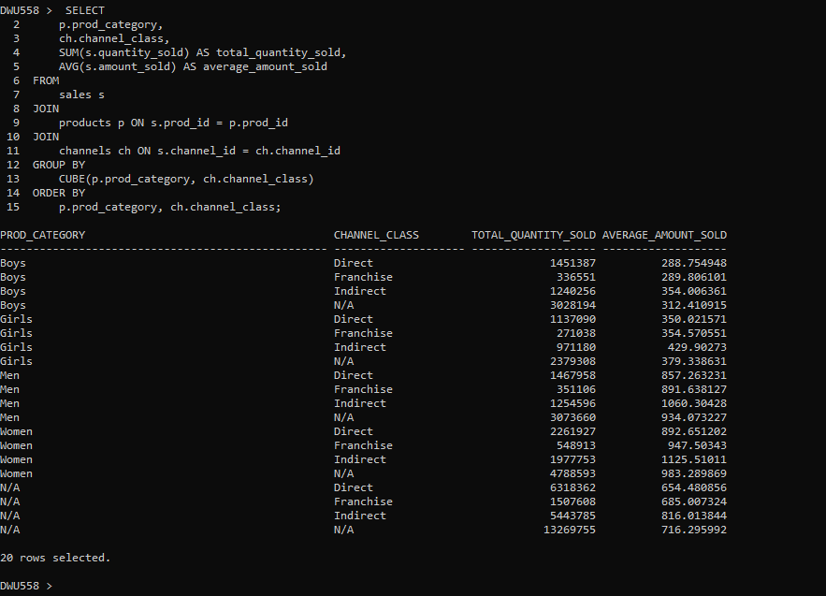 Fig 17: Output by Using CUBE Query

- Using set operation UNION ALL (and not CUBE), write an SQL query that produces the same result as the query in (i) above. Provide output of successful execution of your query.(3 marks)

Here we have performed the same aggregation operation on same query, carried out by Cube operation Above, by Using Union All. To show the Importance of Cube Operation Function and Equivalent implementation Complexity.
UNION ALL Query | SELECT  p.prod_category,  ch.channel_class,  SUM(s.quantity_sold) AS total_quantity_sold,  AVG(s.amount_sold) AS average_amount_sold  FROM  sales s  JOIN  products p ON s.prod_id = p.prod_id  JOIN  channels ch ON s.channel_id = ch.channel_id  GROUP BY  p.prod_category, ch.channel_class  UNION ALL  SELECT  p.prod_category,  NULL AS channel_class,  SUM(s.quantity_sold) AS total_quantity_sold,  AVG(s.amount_sold) AS average_amount_sold  FROM  sales s  JOIN  products p ON s.prod_id = p.prod_id  GROUP BY  p.prod_category  UNION ALL  SELECT  NULL AS prod_category,  ch.channel_class,  SUM(s.quantity_sold) AS total_quantity_sold,  AVG(s.amount_sold) AS average_amount_sold  FROM  sales s  JOIN  channels ch ON s.channel_id = ch.channel_id  GROUP BY  ch.channel_class  UNION ALL  SELECT  NULL AS prod_category,  NULL AS channel_class,  SUM(s.quantity_sold) AS total_quantity_sold,  AVG(s.amount_sold) AS average_amount_sold  FROM  sales s  ORDER BY  prod_category, channel_class;

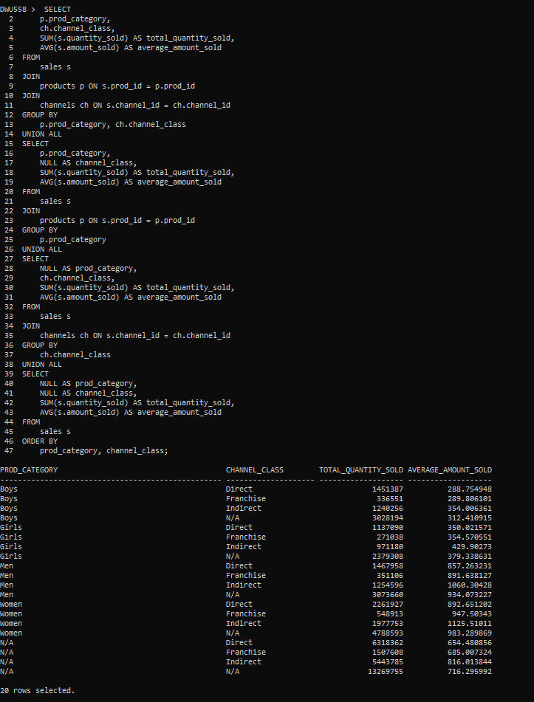
Fig 18 : Output by Combining many Union All Query

- Using EXPLAIN PLAN, provide a detailed discussion analysing performance costs of evaluating the above two queries (i.e., with and without CUBE).
(4 marks)

Explain Plan for Cube Query | EXPLAIN PLAN FOR  SELECT  p.prod_category,  ch.channel_class,  SUM(s.quantity_sold) AS total_quantity_sold,  AVG(s.amount_sold) AS average_amount_sold  FROM  sales s  JOIN  products p ON s.prod_id = p.prod_id  JOIN  channels ch ON s.channel_id = ch.channel_id  GROUP BY  CUBE(p.prod_category, ch.channel_class);  SELECT * FROM TABLE(DBMS_XPLAN.DISPLAY);

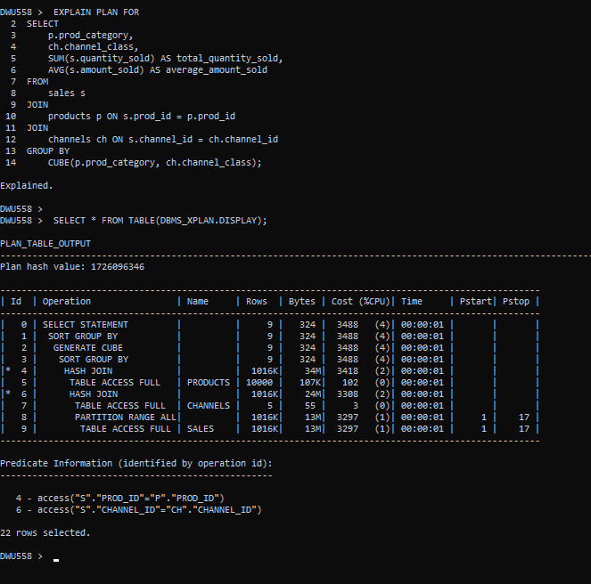
Fig 19 : Explain Plan Using CUBE Query

Explain Plan for Union All Query | EXPLAIN PLAN FOR  SELECT  p.prod_category,  ch.channel_class,  SUM(s.quantity_sold) AS total_quantity_sold,  AVG(s.amount_sold) AS average_amount_sold  FROM  sales s  JOIN  products p ON s.prod_id = p.prod_id  JOIN  channels ch ON s.channel_id = ch.channel_id  GROUP BY  p.prod_category, ch.channel_class  UNION ALL  SELECT  p.prod_category,  NULL AS channel_class,  SUM(s.quantity_sold) AS total_quantity_sold,  AVG(s.amount_sold) AS average_amount_sold  FROM  sales s  JOIN  products p ON s.prod_id = p.prod_id  GROUP BY  p.prod_category  UNION ALL  SELECT  NULL AS prod_category,  ch.channel_class,  SUM(s.quantity_sold) AS total_quantity_sold,  AVG(s.amount_sold) AS average_amount_sold  FROM  sales s  JOIN  channels ch ON s.channel_id = ch.channel_id  GROUP BY  ch.channel_class  UNION ALL  SELECT  NULL AS prod_category,  NULL AS channel_class,  SUM(s.quantity_sold) AS total_quantity_sold,  AVG(s.amount_sold) AS average_amount_sold  FROM  sales s  ORDER BY  prod_category, channel_class;  SELECT * FROM TABLE(DBMS_XPLAN.DISPLAY);
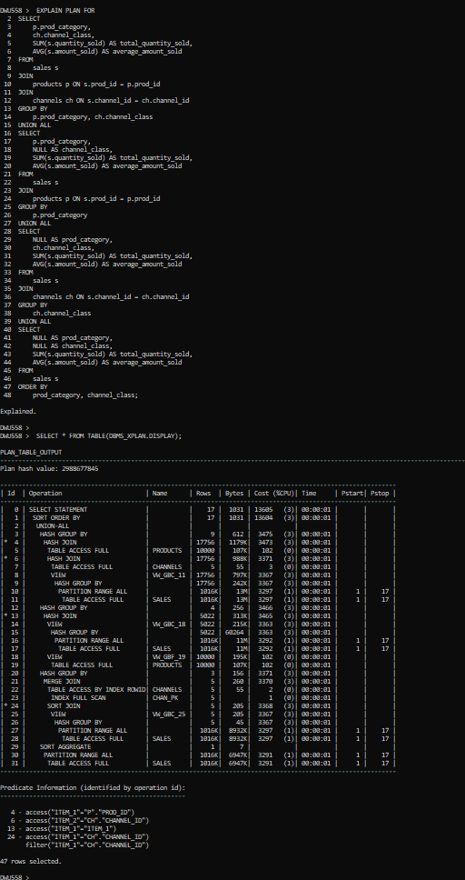
Fig 20 : Explain Plan Using Union All Query

